60004210210

Amartya Mishra

COMPS – C31

ML Experiment 5

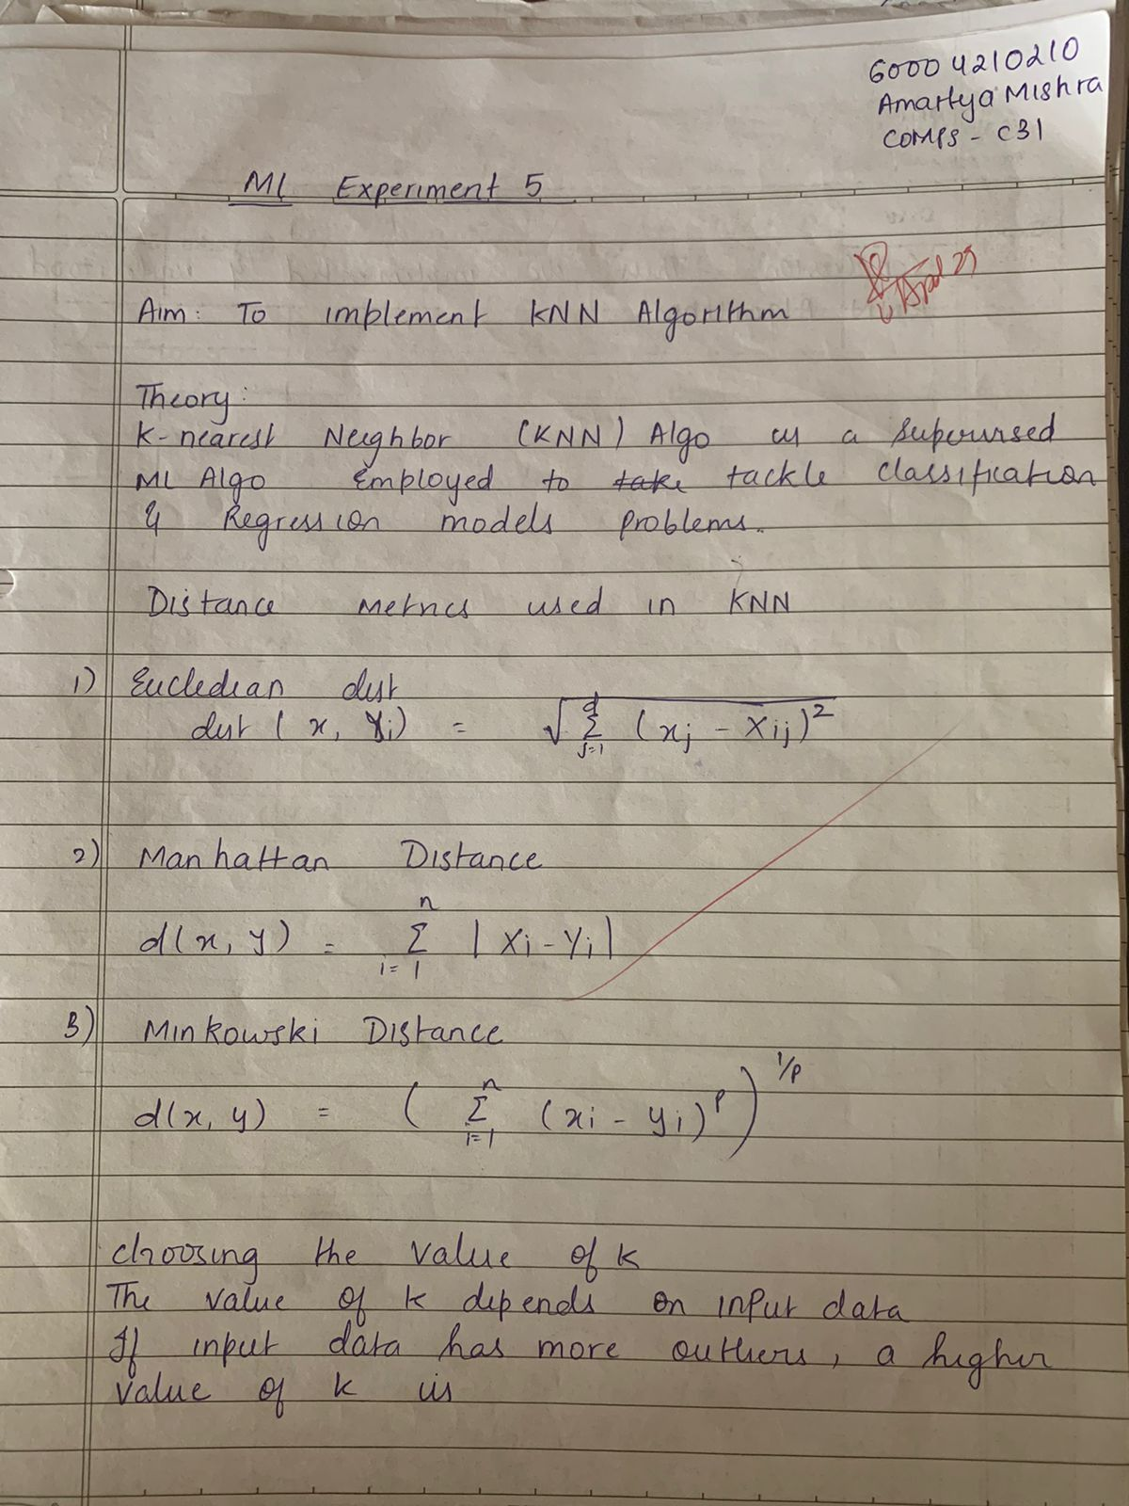



**Implementation:**

import numpy as np

import matplotlib.pyplot as plt

import pandas as pd

from sklearn.datasets import load_digits

from sklearn.decomposition import PCA

from sklearn.preprocessing import StandardScaler

digits_data = load_digits()

X = digits_data.data

scaler = StandardScaler()

X_scaled = scaler.fit_transform(X)

pca = PCA()

X_pca = pca.fit_transform(X_scaled)

eigenvalues = pca.explained_variance_

plt.figure(figsize=(10, 6))

plt.plot(range(1, len(eigenvalues) + 1), eigenvalues, marker='o', linestyle='-')

plt.title('Elbow Method for Optimal Number of Components')

plt.xlabel('Number of Components')

plt.ylabel('Eigenvalues (Explained Variance)')

plt.grid(True)

plt.show()

optimal_num_components = 10

X_reduced = X_pca[:, :optimal_num_components]

df_reduced = pd.DataFrame(X_reduced, columns=[f'PC{i}' for i in range(1, optimal_num_components + 1)])

df_reduced['target'] = digits_data.target

df_reduced.to_csv('reduced_digits_dataset.csv', index=False)

print("Digits Wine dataset saved successfully.")



